A multi-sensor evaluation of precipitation uncertainty for landslide-triggering storm events

Elsa Culler

Andrew Badger

Toby Minear

Kristy Tiampo

Ben Livneh

Extreme precipitation can have profound consequences for communities, resulting in flooding and rainfall-triggered landslides, causing casualties and extensive damage each year. A key challenge to understanding and predicting these natural hazards comes from uncertainties in the depth and intensity of precipitation preceding the landslide event. Practitioners and researchers must select among a wide range of precipitation products, often with little guidance. Here we investigate the degree of precipitation uncertainty across multiple precipitation products for a large set of landslide-triggering storm events and assess the impact of uncertainties on predicted landslide probability using published intensity-duration thresholds. First, we compare the average intensity, peak intensity at the smallest interval available, duration and NOAA Atlas return periods of the landslide-triggering storms, at 257 landslide locations across the continental US and Canada. Precipitation data are taken from five products that cover disparate measurement methods: near real-time and post-processed satellite (Global Precipitation Mission IMERG Early and Final calibrated precipitation), radar (Multi-Radar Multi-Sensor gauge bias-corrected precipitation), gauge (North American Land Data Assimilation System v. 2 Forcing precipitation), and numerical weather prediction (High-Resolution Rapid Refresh real-time precipitation). These products also cover a range of spatial and temporal resolutions as well as spatial extent and real-time or near real-time availability. Landslide-triggering precipitation was found to vary extensively on the basis of the measurement source with the depth of individual storm events diverging by as much as 247 mm with an average range of 38 mm. Peak intensity measurements, which is also potentially influential in triggering landslides, were also highly variable with an average range of 8.8 mm/hr and at times as much as 72 mm/hr. Next, we compare the intensity and duration of storms at landslide sites to existing published Intensity-Duration Thresholds to determine which products achieve the highest Equitable Threat Score for landslide predictions using these existing models. Finally, we discuss the implications of precipitation uncertainty in the context of real-time landslide predictions, to provide guidance for practitioners and researchers on strengths and weaknesses of different products and approaches.

# Introduction

In spite of the destructive nature of landslides, these events remain challenging to forecast (Kirschbaum and Stanley 2018). There are many sources of uncertainty that contribute to poor landslide predictions such as soil property, vegetation, and anthropogenic modifications to surface and subsurface soil structure. Perhaps the largest source of uncertainty in landslide probability estimates, is hydrologic uncertainty, here defined as uncertainty in the depth and intensity of liquid precipitation leading up to the event (Chowdhury and Flentje 2002). A confounding factor is the wide range precipitation datasets ranging from in situ observations, ground-based radar and remotely sensed retrievals. The goal of this analysis is to investigate the role of precipitation uncertainty and subsequently the uncertainty in landslide risks. A greater understanding areas of relative agreement and divergence across products may provide guidance to practitioners and researchers choosing precipitation products for studying landslides.

## Precipitation sensors and estimates

The precipitation products chosen for this inter-comparison represent three broad categories of precipitation measurements as their primary component: precipitation gauges, ground-based radar, and microwave satellite. Precipitation gauges operate by periodically measuring how much precipitation has landed in a bucket. Their main strength is they directly measure the amount of water that lands in the bucket, but nonetheless they suffer from spatial and temporal inconsistencies as a result of wind (Pollock et al. 2018), instrument design (Duchon, Fiebrich, and Grimsley 2014, [@duchonUndercatchTippingbucketGauges2010]), poor instrument placement (Vose et al. 2014), lack representativeness of the surrounding area, and global sensor density (Kidd et al. 2017). Ground-based radar can detect precipitation based on propagation and backscatter of radar, and therefore can detect variation in precipitation potentially hundreds of kilometers away. Like any indirect measurement of precipitation, radar must convert the radar signal to precipitation volume and to remove the influence of other objects from buildings or insects in the radar’s path (Fornasiero et al., n.d., [@bousquetObservationsImpactsUpstream2003], [@nikahdReviewUncertaintySources2016]). Most ground-based radars use multiple bands of radar and multiple polarities in order to compute the raindrop shape and size distributions used in the processing, which is an advantage of ground-based radar over many satellite sensors (Chandrasekar et al. 2008). Satellites can use any of a number of sensors to detect precipitation including active and passive microwave, infrared, radar, or any combination, and they can also be deployed in geostationary or low Earth orbits that cover particular regions at particular intervals. The key advantage of satellite-based precipitation measurements is that unlike ground-based sensors they can provide frequent, spatially homogenous, global precipitation measurements, although typically multiple satellites are required to develop such a product (Tapiador et al. 2012). However, since each type of satellite-based sensor has its own set of strengths and weaknesses that are beyond the scope of this study, many of the challenges of satellite-based precipitation measurement are related to sensor calibration, bias-correction relative to ground-based measurements (Ebert 2007), and the development of algorithms for merging measurements from diverse sources (Huffman et al. 2007).

## Precipitation datasets for forecasting or nowcasting landslides

Though precipitation measurements have been compared on the basis of any number of metrics in prior studies ranging from annual totals to the largest number of consecutive dry days, in this study the choice of metrics was guided by what might be useful to researchers and practitioners interested in forecasting and responding to rainfall-triggered landslides.

While some landslides are triggered by short, intense precipitation events, others are triggered by the complete saturation of the soil column that occurs over a longer period of time (Cannon and Gartner 2005). However, in both of these cases the triggering event occurs over the course of hours or days rather than months or years, and for some landslides the critical time period may be less than an hour of intense rainfall. As a result, we selected precipitation products with hourly or finer temporal resolution (see sec. 2.2) and evaluated them over individual storm events. Satellite products tend to capture the higher-intensity precipitation (Sun et al. 2018) that can be key in triggering landslides. This may be due to the measurement method or the generally higher temporal resolution of satellite products.

When precipitation is used to provide warning systems or guide recovery efforts from landslides, it is important to be able to provide that information in a timely manner (Kirschbaum et al. 2012). Low latency is therefore vital in a precipitation product used to forecast or nowcast landslides. This study also will assess whether the low latency comes at a cost relative to landslide forecasting skill for the selected products.

Finally, many precipitation products struggle in mountainous regions (Sun et al. 2018), precisely where landslides are most likely to occur due to higher slopes. This study includes an analysis in the spatial variation in performance to assess the role of topography in the results.

## Precipitation product comparisons

Sun et al. (2018) reviewed 30 gauge-based, satellite-based, and reanalysis global precipitation products, comparing annual precipitation estimates, 90th percentile of daily precipitation, systematic and random error for daily precipitation, and regional differences in performance. They found a great deal of variability even within the same class of product (e.g. a deviation of 300 mm in annual precipitation for some). They conclude that cross validating across multiple datasets is crucial to account for errors, and that the placement and density of gauges accounts for many of the errors in gauge-based or gauge-corrected products.

Adler et al. (2001) similarly analyzed 31 gauge-based, satellite-based, model-based, and climatological datasets, comparing monthly precipitation, precipitation by latitude, and inter-annual change. They found that ‘quasi-standard’ products, e.g. those like the Global Precipitation Measurement mission (GPM) (Hou et al. 2014) that have undergone substantial testing, perform better. Additionally, they found that products incorporating both in situ and satellite information (e.g. the Global Precipitation Climatology Project [GPCP] (Adler et al. 2003)) perform better than products based on a single data source.

## Inter-comparison of extreme precipitation

Fewer studies comparing extreme precipitation exist (Amitai et al. 2012, [@manzanasPrecipitationVariabilityTrends2014], [@hashmiComparisonSDSMLARSWG2011], [@tryhornComparisonTechniquesDownscaling2011]), primarily looking at extreme precipitation indicators like 90th percentile precipitation, extreme one-day precipitation and maximum number of consecutive wet days. These measures are meant to capture large storms that happen on at least an annual basis rather than storms that rise to the level of a natural disaster (Sun et al. 2018; Manzanas et al. 2014). Because this study is focusing on rainfall-triggered landslides, it will focus instead on the total storm depth, duration, average intensity, and peak intensity of precipitation events known to precede landslides in North America.

## Intensity-Duration Thresholds for landslide prediction

Intensity-Duration Thresholds are a type of single-parameter statistical model used for landslide early warning systems, where rainstorms above the curve are predicted to cause landslides (Scheevel et al. 2017). The curves are typically valid in a particular region or climate and for a range of durations based on the training data (Guzzetti et al. 2008). This study will use a selection of power-law Intensity-Duration Thresholds from those included in a review by Guzzetti et al. (2008) to preliminarily compare the suitability of precipitation measurements from different sources for providing early warning or near-real time support to disaster response organizations.

Given the wide-ranging issues associated with precipitation observations cited above, as well as the importance of understanding and anticipating landslide events, this study presents a multi-product, multi-site analysis to understand landslide-triggering storms. We thereby address a gap in the literature when it comes to evaluating extreme precipitation through the lens of natural hazards. This work furthers the analysis by Rossi et al. (2017) who compared gauge and satellite precipitation for the purposes of landslide modeling by additionally including a ground-based radar product and by singling out observations preceding specific landslide events.

In sec. 2, we will discuss landslide site and precipitation product selection, followed by procedures for splitting precipitation into storms and the metrics used in the comparison. Sec. 3 begins with the cumulative precipitation over the 30-days preceding the landslide for 5 characteristic example sites. Next, we compare each product using storm characteristics of total depth, duration, total intensity, peak intensity, and return period. To test whether peak intensity might be accounting for low return period storms causing landslides, we compare the two. Finally, we use established intensity-duration thresholds to test which products have the best separation between landslides and other rainfall, comparing the hit ratio and the false alarm ratio for each product and threshold.

# Methods

## Study domain and landslide site selection

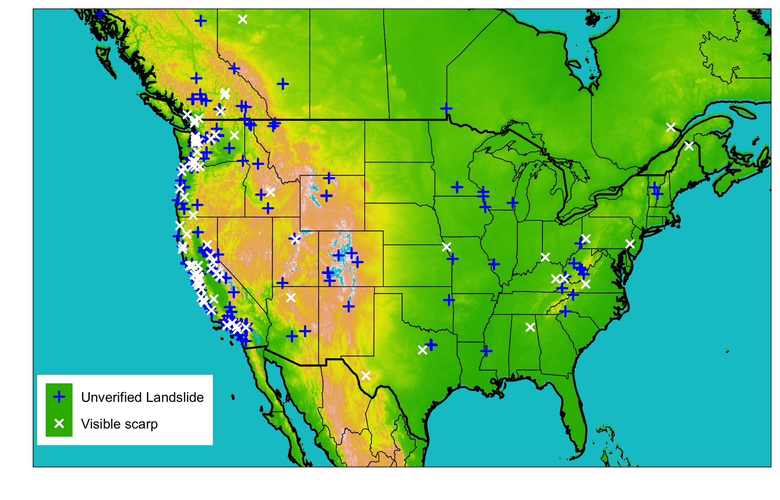

Map of all landslide sites colored by whether or not the location was verified using aerial satellite imagery.

## Precipitation data sources

### Ground-based precipitation gauges

* Measure precipitation directly
* Rain gauges are typically considered reference measurements because they the most direct measurement of precipitation (Tapiador et al. 2012).
* Gauges cover a small proportion of land area and are not uniformly distributed, and so only 6.5% of the Earth’s land area between ${60}^{o}$ N and ${60}^{o}$ S is within 5 km of a gauge (Kidd et al. 2017). As a result, many precipitation products used gauge measurements to correct biases in more homogeneous but indirect measurements.

### Ground-based radar

* Indirect estimate of precipitation based on the return echo power from radar.
* Unlike gauges, radar can detect variability in precipitation over an area rather than a single measurement that may not be representative. Radar estimates are commonly combined with gauge measurements to fill sampling voids in the gauge network (Tapiador et al. 2012).
* Though ground-based radar can cover an area instead of a single point like a gauge, a high-density sensor network is still required for continuous spatial coverage.

### Satellite

* Satellite-based sensors included in the products used in this study are active and passive microwave, infrared and radar.(Kidd et al. 2020)
* Satellites can provide global, homogeneous coverage. However, as indirect measurements of precipitation where the relationship between the measurement and precipitation can vary by season and location, satellite products require extensive validation and calibration using ground-based methods (Tapiador et al. 2012).

Table 1: 3 Precipitation products that will be used to characterize the degree of hydrologic uncertainty present immediately before and during landslide events

|  |  |  |  |  |
| --- | --- | --- | --- | --- |
| Precipitation product | Description | Spatial Resolution | Temporal resolution | Typical Latency |
| Integrated Multi-satellitE Retrievals for Global precipitation measurement (IMERG) early run (Hou et al. 2014) | Global network of satellites unified by measurements from a single reference radar/radiometer satellite. | ${.1}^{o}$ (~10 km) | 30 minutes | 4 hours |
| Integrated Multi-satellitE Retrievals for Global precipitation measurement (IMERG) final run (Hou et al. 2014) | In addition to the satellite data included in the IMERG early run, the final run includes late-arriving microwave overpasses, monthly gauge-based adjustments, and an algorithm that interpolates forward as well as backward in time. | ${.1}^{o}$ (~10 km) | 30 minutes | 3.5 months |
| Multi-Radar Multi-Sensor (MRMS) (Zhang et al. 2015) | Integrates data from radars, satellites, precipitation gages, and other sensors to provide real-time decision support | 1 km | 2 minutes | < 5 minutes |
| National Land Data Assimilation System version 2 (NLDAS-2) forcing (Xia et al. 2012) | Disaggregation of Climate Prediction Center daily precipitation using bias-corrected radar | ${.125}^{o}$ (~ 12 km) | 1 hour | 4 days |
| NOAA High-Resolution Rapid Refresh (HRRR) model (Alexander et al. 2016) | Numerical Weather Prediction with radar assimilation. | $3$ km | 1 hour | 1-36 hour forecasts updated hourly |

## Identify storm events

* A storm is continuous separated by no more than 24 hours of below-threshold precipitation
* For the purposes of calculating frequency, the maximum precipitation period for each applicable NOAA atlas duration was identified. For example, to find the 5-hour storm return period, the 5-hour precipitation total within the landslide-triggering storm was used. Where a single frequency value was required

## Precipitation comparison for all storms

* Measure of the bias of each product relative to the rest of the measurements
* Measure of the variability of the measurements for each storm

## Precipitation comparison for landslide-triggering storms

* Measure of the bias of each product relative to the rest of the measurements
* Measure of the variability of the measurements for each storm

## Precipitation comparison for use in Intensity-Duration Thresholds

* Intensity-Duration thresholds are simple landslide models whereby a threshold is defined as a power law of the storm duration, and raw or normalized intensities above the threshold predict a landslide. Thresholds were obtained from (Guzzetti et al. 2008), who compiled them from the literature. Thresholds were used on applicable subsets of the data based on climate or other conditions.
* Computed the hit ratio, false alarm ratio, and threat score for each product and threshold.

# Results

## Precipitation comparison for typical storms

### What are some of the ways in which precipitation measurements differ among different products at select sites?

* The precipitation measurements differ substantially in correlation, cumulative volume, and landslide-triggering storm volume.
* Example sites in fig. 1 demonstrate some different degrees and types of variation that occurred at various sites.
* As shown in fig. 1, products that share data sources such as the IMERG products are sometimes but not always more similar to each other than to other products.

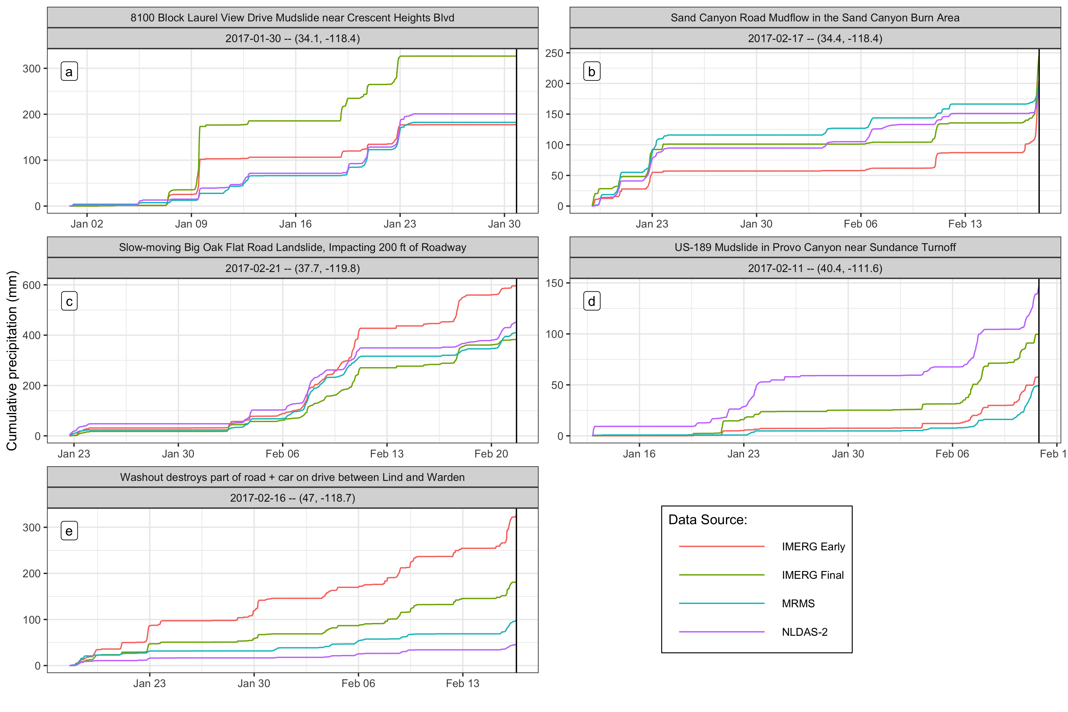

Figure 1: Cumulative precipitation measurements at selected landslide sites for the 30 days before the event. The precipitation is variable across the different products, and the selected sites each demonstrate diverse types of variability. Panel (a) shows a site where no landslide-triggering precipitation was detected by any product, suggesting a location error in the landslide record. In panel (b), the IMERG Early product reports nearly 50mm less cumulative precipitation leading into the landslide-triggering storm, but then makes up the difference by detecting much more precipitation immediately before the landslide. Panel (c) shows similar measurements among all products while in panel (d) there is a wide spread of approximately two-thirds the maximum total amount of precipitation. Finally, in panel (e) all products are well correlated, but the volumes do not match.

## Precipitation comparison for landslide-triggering storms

### Is there consistent bias among precipitation products?

* Generally, the IMERG products have higher day-of-landslide precipitation rank than MRMS which has higher rank than NLDAS-2
* IMERG Early has by some 300mm the highest precipitation measurements in millimeters.
* The range of z-scores for each product is comparable, suggesting that each product is an outlier at some sites

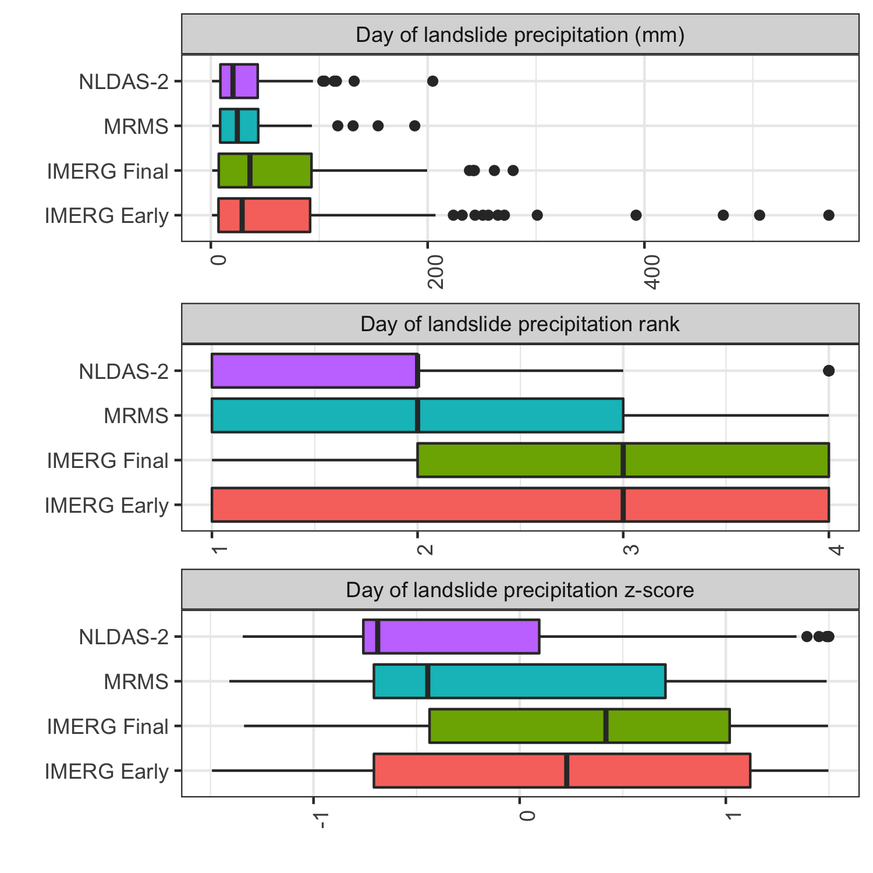

Rank and z-score for day-of-landslide precipitation as measured by each product. The IMERG products tend to have higher rank than MRMS, which typically exceeds NLDAS-2 measurements. The z-scores reflect the same order, but also a similar range of variability across all products.

### How does each precipitation product capture key elements of landslide-triggering storms?

* The IMERG products measure higher peak hourly intensities, which is likely at least partially due to the shorter 30-minute time step.
* The higher peak intensities are also reflected in longer return periods.
* There are many outliers on the low end of the depth and duration measurements, while the total intensity measurements remain close to the ensemble mean.
* Among the verified locations, there are not as many low values either close to the mean or outliers.
* There are also fewer high return periods among the ground-based products MRMS and NLDAS-2 among the verified locations

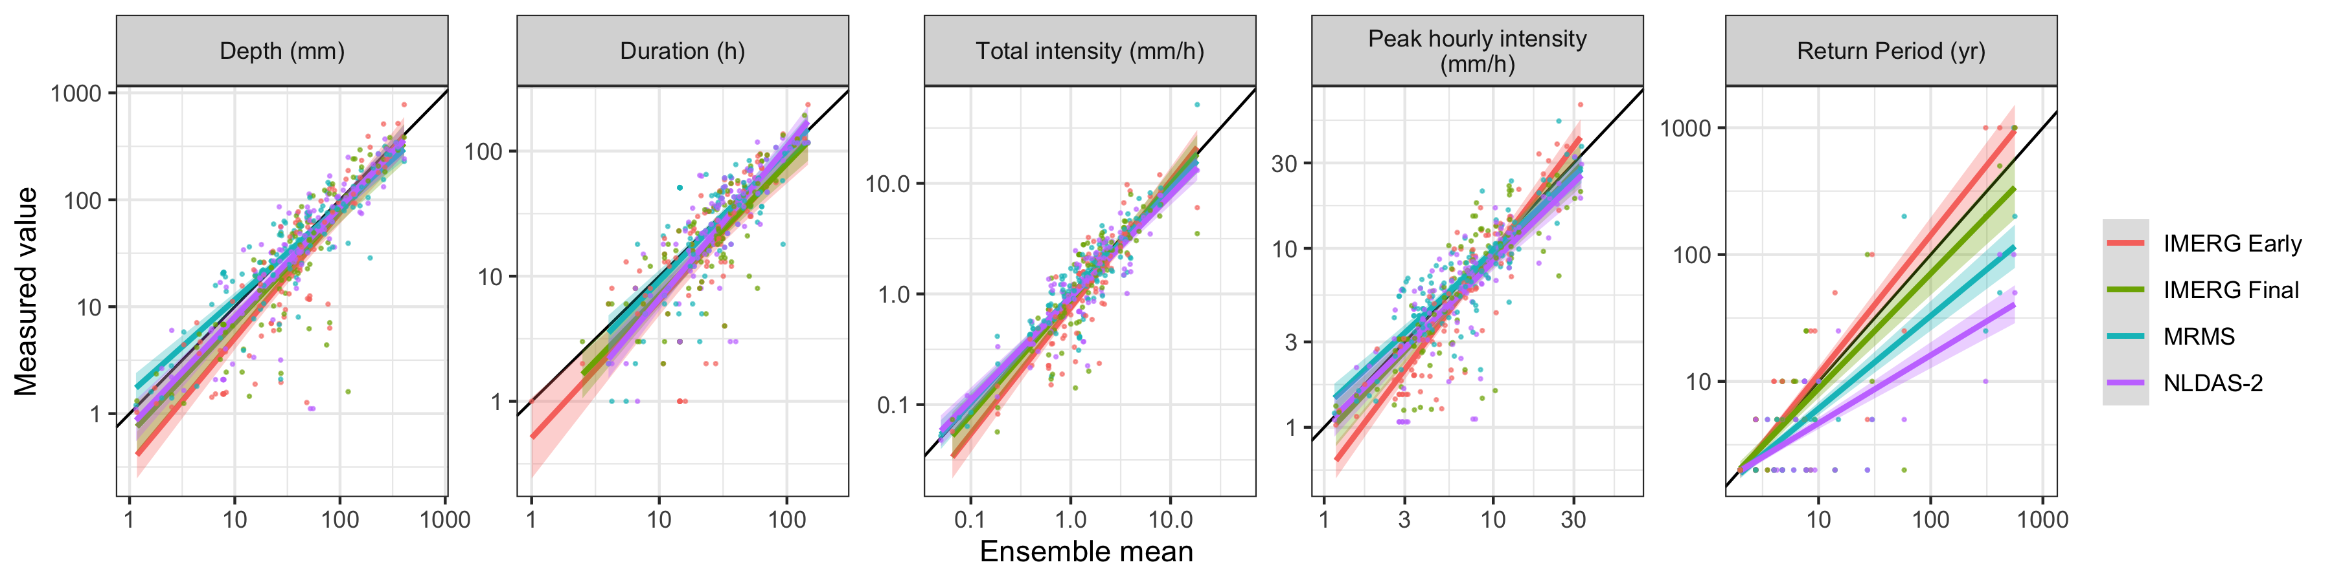

Storm characteristics as measured by each product along with trend lines. The IMERG products measure higher peak hourly intensities, which is likely at least partially due to the shorter 30-minute time step. The higher peak intensities are also reflected in longer return periods. In general there appears to be good agreement among products on the depth and duration of storms, with the exception of outlying low measurements.

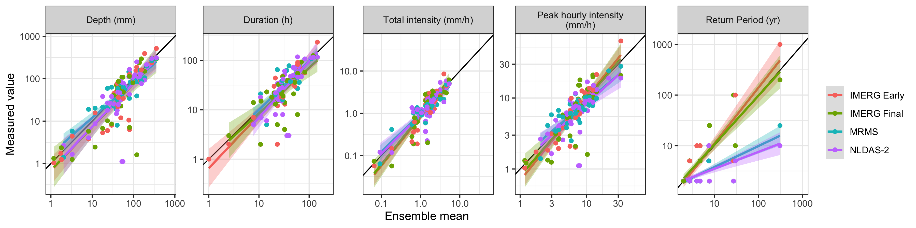

### Can peak intensity account for relatively high return period storms causing landslides?

* There appears to be a positive correlation between return period and peak intensity, but this relationship drops off for most products for the the higher return periods.

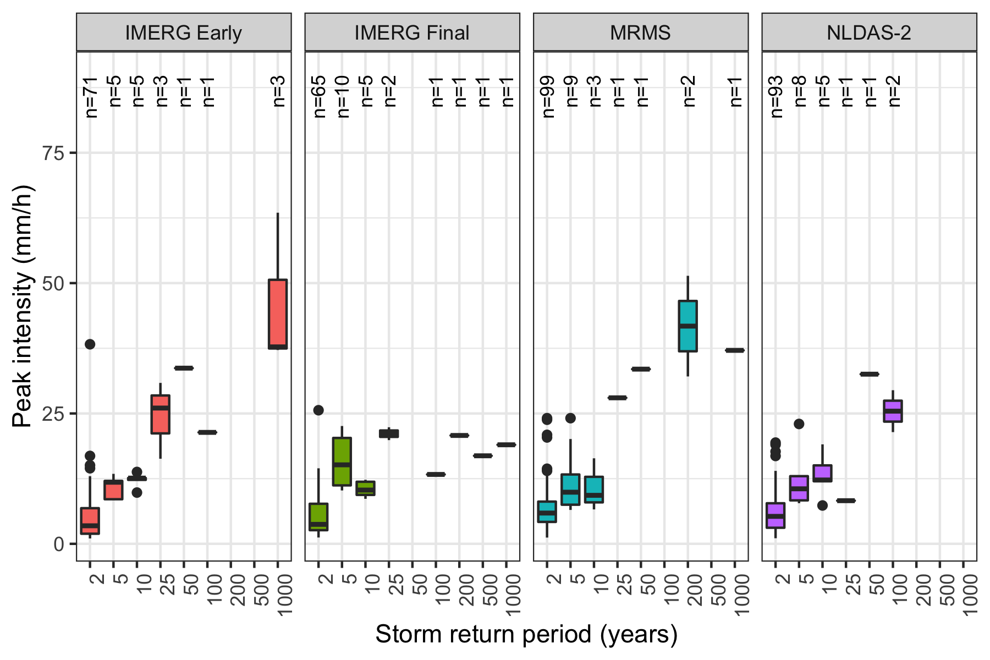

Peak intensity vs. storm return period. There appears to be a positive correlation between return period and peak intensity, but this relationship drops off for most products among the higher return periods.

### How does each product compare if it were used to predict landslides using an industry standard method of intensity-duration curves?

* These models tend to perform better using MRMS or NLDAS-2 data than using either IMERG product.
  + The IMERG products seem to be more sensitive to both high intensity precipitation and low intensity precipitation
  + The low intensity precipitation may be erroneous noise slightly above the 1mm threshold that causes the storm detection algorithm to select too long of a storm in some cases.
  + Artificially lengthened storms would be expected to have lower intensity values for the whole storm.
* The choice of model does not appear to make as much difference in performance as the choice of precipitation measurement source.
* All models have a better hit ratio when using only verified landslide sites.

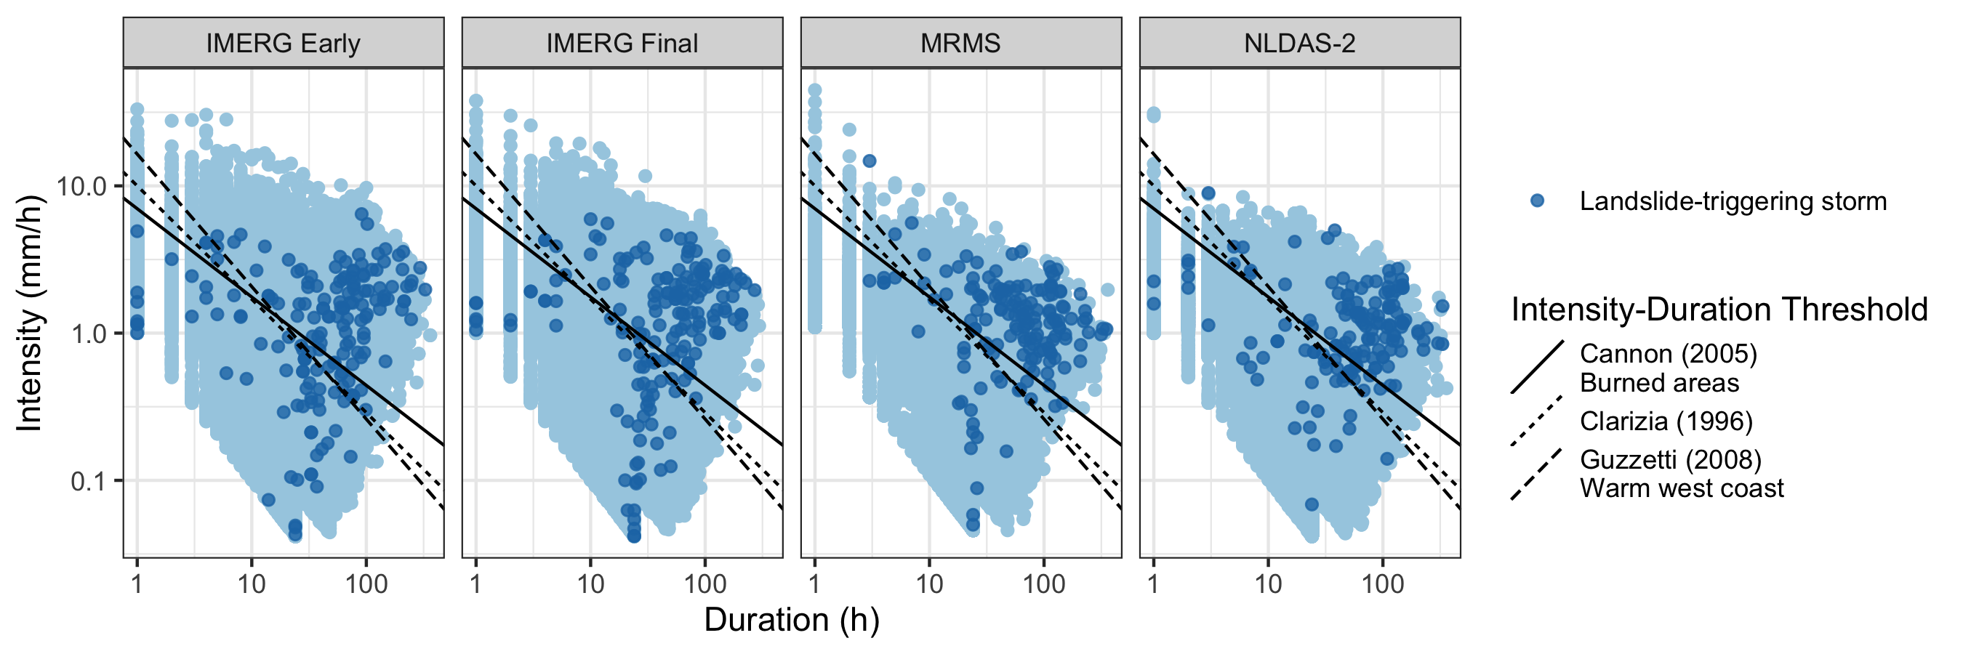

Each storm in the precipitation record and established global or climactic Intensity-Duration Thresholds. Landslide-triggering storms are marked. It appears that these models generally perform better when using MRMS or NLDAS-2 data, since the IMERG products detect a larger number of low intensity values for landslide-triggering storms.

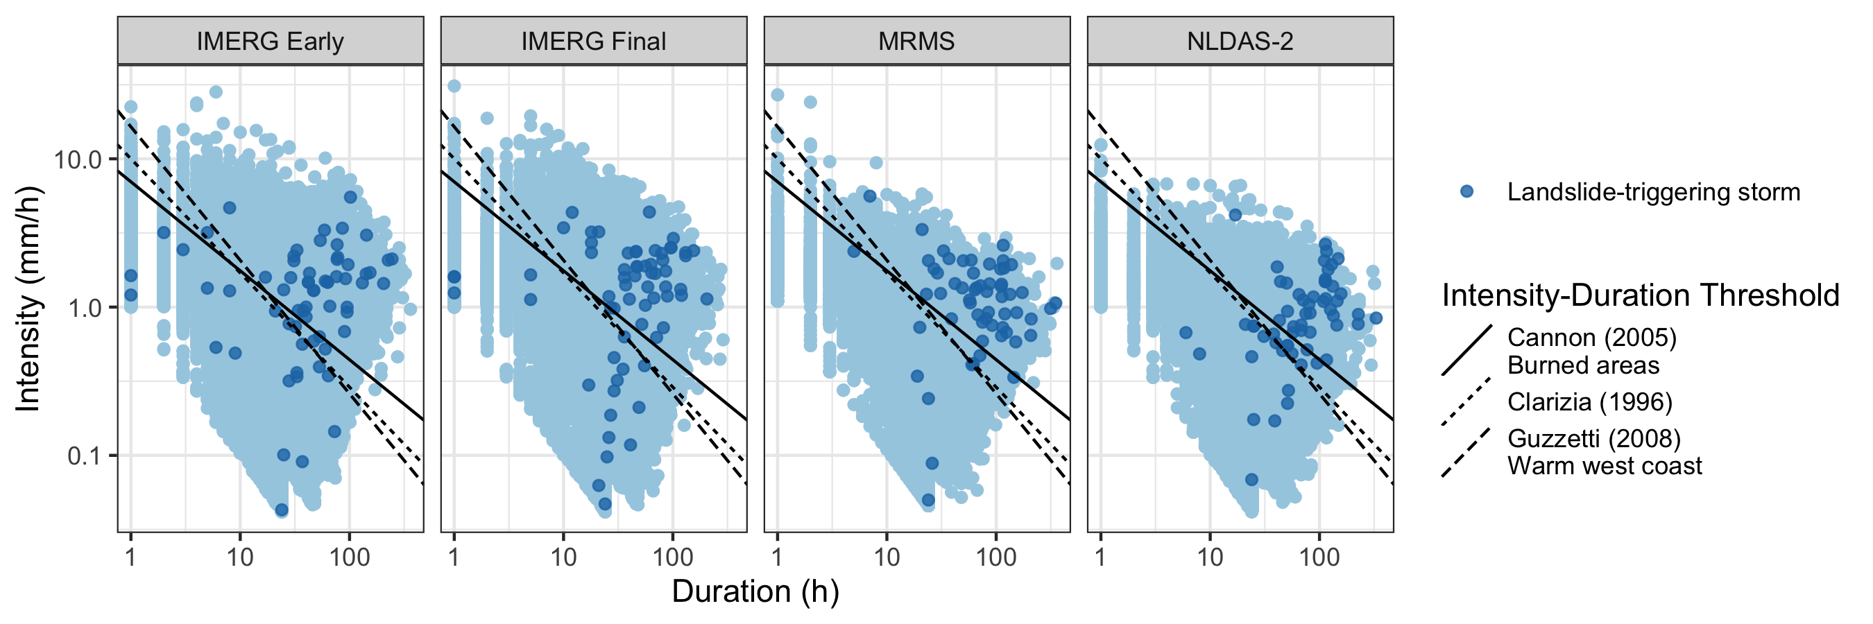

Table 2: Threat score, hit ratio, and false alarm ratio for each product and the Guzzetti (2008) Intensity Duration Threshold

|  |  |  |  |  |  |  |
| --- | --- | --- | --- | --- | --- | --- |
| Product | Include | **Hits** | **Misses** | **Threat score** | **Hit ratio** | **False alarm ratio** |
| GPM IMERG Early | All | 114 | 62 | 0.00676598 | 0.6477273 | 0.2694975 |
|  | Verified | 44 | 21 | 0.006588799 | 0.6769231 | 0.2980977 |
| GPM IMERG Final | All | 117 | 60 | 0.00631068 | 0.6610169 | 0.3074026 |
|  | Verified | 45 | 19 | 0.006249132 | 0.7031250 | 0.3389533 |
| NLDAS-2 | All | 114 | 40 | 0.01433421 | 0.7402597 | 0.2213864 |
|  | Verified | 45 | 14 | 0.014768625 | 0.7627119 | 0.2228354 |
| MRMS | All | 130 | 26 | 0.02492331 | 0.8333333 | 0.2433511 |
|  | Verified | 52 | 7 | 0.023245418 | 0.8813559 | 0.2635528 |

## Resolution

### Do products produce comparable results when compared at equal temporal and spatial resolution, or are there other underlying differences?

* FIGURE 8: Scatter volume, intensity, frequency, and peak intensity for each product with matched spatial resolution, temporal resolution, and both
* FIGURE 9: Intensity-Duration Threshold example for each product with matched spatial resolution, temporal resolution, and both

# Discussion

* The satellite products identify to have higher peak intensities and return periods. They also were more sensitive at detecting anomalously low precipitation values, in particular the IMERG Early product.
* Precipitation measurements at verified landslide sites tended to be higher than those at other sites, suggesting that the actual landslide location was too far away from the recorded location for the precipitation measurements to be representative.
* Intensity-Duration Thresholds performed reasonably well at identifying landslides considering that they were trained on different types of data and designed to cover large regions. However, they fared more poorly at excluding false alarms.
* [Degree to which resolution and location accuracy affected performance of Intensity-Duration Thresholds]
* Other factors impacting precipitation measurements could include climate and topography of landslide locations, the density of ground-based sensors,
* Landslide susceptibility caused by slope, soil type, recent wildfire or disturbance, and infrastructure placement could also affect the precipitation intensity or duration needed to trigger a landslide

# Conclusion

* A major limitation to studies like this is the lack of exact and verified landslides, shown in the results for exact landslide locations as compared to inexact locations. This can be addressed by a manual search as in this study or perhaps in the future by machine learning.
* Precipitation products differ greatly in measurement values for the same time and location
* As a result, precipitation products differ in their ability to predict landslides
* Implications for developing early warning systems for landslides across broad regions using remotely sensed precipitation

# Bibliography

Adler, Robert F., George J. Huffman, Alfred Chang, Ralph Ferraro, Ping-Ping Xie, John Janowiak, Bruno Rudolf, et al. 2003. “The Version-2 Global Precipitation Climatology Project (GPCP) Monthly Precipitation Analysis (1979Present).” *Journal of Hydrometeorology* 4 (6): 1147–67. [https://doi.org/10.1175/1525-7541(2003)004<1147:TVGPCP>2.0.CO;2](https://doi.org/10.1175/1525-7541(2003)004%3C1147:TVGPCP%3E2.0.CO;2).

Adler, Robert F, Christopher Kidd, Grant Petty, Mark Morissey, and H Michael Goodman. 2001. “Intercomparison of Global Precipitation Products: The Third Precipitation Intercomparison Project (PIP-3).” *Bulletin of the American Meteorological Society*, 20.

Alexander, Curtis, David Dowell, Stan Benjamin, Stephen Weygandt, Joseph Olson, Jaymes Kenyon, Georg Grell, et al. 2016. “The Hourly Updated US High-Resolution Rapid Refresh (HRRR) Storm-Scale Forecast Model.” In *EGU General Assembly Conference Abstracts*, 1.

Amitai, E., W. Petersen, X. Llort, and S. Vasiloff. 2012. “Multiplatform Comparisons of Rain Intensity for Extreme Precipitation Events.” *IEEE Transactions on Geoscience and Remote Sensing* 50 (3): 675–86. <https://doi.org/10.1109/TGRS.2011.2162737>.

Bousquet, Olivier, and Bradley F. Smull. 2003. “Observations and Impacts of Upstream Blocking During a Widespread Orographic Precipitation Event.” *Quarterly Journal of the Royal Meteorological Society* 129 (588): 391–409. <https://doi.org/10.1256/qj.02.49>.

Cannon, Susan H, and Joseph E Gartner. 2005. “Wildfire-Related Debris Flow from a Hazards Perspective.” In *Debris-Flow Hazards and Related Phenomena*, 23.

Chandrasekar, V., Arthur Hou, Eric Smith, V. N. Bringi, S. A. Rutledge, E. Gorgucci, W. A. Petersen, and Gail Skofronick Jackson. 2008. “POTENTIAL ROLE OF DUAL-POLARIZATION RADAR IN THE VALIDATION OF SATELLITE PRECIPITATION MEASUREMENTSRationale and Opportunities.” *Bulletin of the American Meteorological Society* 89 (8): 1127–46. <https://doi.org/10.1175/2008BAMS2177.1>.

Chowdhury, Robin, and Phil Flentje. 2002. “Uncertainties in Rainfall-Induced Landslide Hazard.” *Quarterly Journal of Engineering Geology and Hydrogeology* 35 (1): 61–69. <https://doi.org/10.1144/qjegh.35.1.61>.

Duchon, C. E., and C. J. Biddle. 2010. “Undercatch of Tipping-Bucket Gauges in High Rain Rate Events.” *Advances in Geosciences* 25 (March): 11–15. <https://doi.org/10.5194/adgeo-25-11-2010>.

Duchon, Claude, Christopher Fiebrich, and David Grimsley. 2014. “Using High-Speed Photography to Study Undercatch in Tipping-Bucket Rain Gauges.” *Journal of Atmospheric and Oceanic Technology* 31 (6): 1330–6. <https://doi.org/10.1175/JTECH-D-13-00169.1>.

Ebert, Elizabeth E. 2007. “Methods for Verifying Satellite Precipitation Estimates.” In *Measuring Precipitation from Space*, edited by Vincenzo Levizzani, Peter Bauer, and F. Joseph Turk, 345–56. Dordrecht: Springer Netherlands. <https://doi.org/10.1007/978-1-4020-5835-6_27>.

Fornasiero, A, R Amorati, P P Alberoni, L Ferraris, and A C Taramasso. n.d. “Impact of Combined Beam Blocking and Anomalous Propagation Correction Algorithms on Radar Data Quality,” 8.

Guzzetti, Fausto, Silvia Peruccacci, Mauro Rossi, and Colin P. Stark. 2008. “The Rainfall IntensityDuration Control of Shallow Landslides and Debris Flows: An Update.” *Landslides* 5 (1): 3–17. <https://doi.org/10.1007/s10346-007-0112-1>.

Hashmi, Muhammad Zia, Asaad Y. Shamseldin, and Bruce W. Melville. 2011. “Comparison of SDSM and LARS-WG for Simulation and Downscaling of Extreme Precipitation Events in a Watershed.” *Stochastic Environmental Research and Risk Assessment* 25 (4): 475–84. <https://doi.org/10.1007/s00477-010-0416-x>.

Hou, Arthur Y., Ramesh K. Kakar, Steven Neeck, Ardeshir A. Azarbarzin, Christian D. Kummerow, Masahiro Kojima, Riko Oki, Kenji Nakamura, and Toshio Iguchi. 2014. “The Global Precipitation Measurement Mission.” *Bulletin of the American Meteorological Society* 95 (5): 701–22. <https://doi.org/10.1175/BAMS-D-13-00164.1>.

Huffman, George J., David T. Bolvin, Eric J. Nelkin, David B. Wolff, Robert F. Adler, Guojun Gu, Yang Hong, Kenneth P. Bowman, and Erich F. Stocker. 2007. “The TRMM Multisatellite Precipitation Analysis (TMPA): Quasi-Global, Multiyear, Combined-Sensor Precipitation Estimates at Fine Scales.” *Journal of Hydrometeorology* 8 (1): 38–55. <https://doi.org/10.1175/JHM560.1>.

Kidd, Chris, Andreas Becker, George J. Huffman, Catherine L. Muller, Paul Joe, Gail Skofronick-Jackson, and Dalia B. Kirschbaum. 2017. “So, How Much of the Earth’s Surface Is Covered by Rain Gauges?” *Bulletin of the American Meteorological Society* 98 (1): 69–78. <https://doi.org/10.1175/BAMS-D-14-00283.1>.

Kidd, Christopher, Yukari N. Takayabu, Gail M. Skofronick-Jackson, George J. Huffman, Scott A. Braun, Takuji Kubota, and F. Joseph Turk. 2020. “The Global Precipitation Measurement (GPM) Mission.” In *Satellite Precipitation Measurement*, edited by Vincenzo Levizzani, Christopher Kidd, Dalia B. Kirschbaum, Christian D. Kummerow, Kenji Nakamura, and F. Joseph Turk, 67:3–23. Cham: Springer International Publishing. <https://doi.org/10.1007/978-3-030-24568-9_1>.

Kirschbaum, Dalia Bach, Robert Adler, Yang Hong, Sujay Kumar, Christa Peters-Lidard, and Arthur Lerner-Lam. 2012. “Advances in Landslide Nowcasting: Evaluation of a Global and Regional Modeling Approach.” *Environmental Earth Sciences* 66 (6): 1683–96. <https://doi.org/10.1007/s12665-011-0990-3>.

Kirschbaum, Dalia, and Thomas Stanley. 2018. “Satellite-Based Assessment of Rainfall-Triggered Landslide Hazard for Situational Awareness.” *Earth’s Future* 6 (3): 505–23. <https://doi.org/10.1002/2017EF000715>.

Manzanas, R., L. K. Amekudzi, K. Preko, S. Herrera, and J. M. Gutiérrez. 2014. “Precipitation Variability and Trends in Ghana: An Intercomparison of Observational and Reanalysis Products.” *Climatic Change* 124 (4): 805–19. <https://doi.org/10.1007/s10584-014-1100-9>.

Nikahd, Ali, Mazlan Hashim, and Mohammad Jafar Nazemosadat. 2016. “A Review of Uncertainty Sources on Weather Ground-Based Radar for Rainfall Estimation.” *Applied Mechanics and Materials*. https://www.scientific.net/AMM.818.254; Trans Tech Publications Ltd. <https://doi.org/10.4028/www.scientific.net/AMM.818.254>.

Pollock, M. D., G. O’Donnell, P. Quinn, M. Dutton, A. Black, M. E. Wilkinson, M. Colli, et al. 2018. “Quantifying and Mitigating Wind-Induced Undercatch in Rainfall Measurements.” *Water Resources Research* 54 (6): 3863–75. <https://doi.org/10.1029/2017WR022421>.

Rossi, Mauro, Dalia Kirschbaum, Daniela Valigi, Alessandro Cesare Mondini, and Fausto Guzzetti. 2017. “Comparison of Satellite Rainfall Estimates and Rain Gauge Measurements in Italy, and Impact on Landslide Modeling.” *Climate* 5 (4): 90. <https://doi.org/10.3390/cli5040090>.

Scheevel, Caroline R., Rex L. Baum, Benjamin B. Mirus, and Joel B. Smith. 2017. “Precipitation Thresholds for Landslide Occurrence Near Seattle, Mukilteo, and Everett, Washington.” Open-File Report 2017-1039. Open-File Report. U.S. Department of the Interior; U.S. Geological Survey.

Sun, Qiaohong, Chiyuan Miao, Qingyun Duan, Hamed Ashouri, Soroosh Sorooshian, and Kuo-Lin Hsu. 2018. “A Review of Global Precipitation Data Sets: Data Sources, Estimation, and Intercomparisons.” *Reviews of Geophysics* 56 (1): 79–107. <https://doi.org/10.1002/2017RG000574>.

Tapiador, Francisco J., F. J. Turk, Walt Petersen, Arthur Y. Hou, Eduardo García-Ortega, Luiz A. T. Machado, Carlos F. Angelis, et al. 2012. “Global Precipitation Measurement: Methods, Datasets and Applications.” *Atmospheric Research* 104-105 (February): 70–97. <https://doi.org/10.1016/j.atmosres.2011.10.021>.

Tryhorn, Lee, and Art DeGaetano. 2011. “A Comparison of Techniques for Downscaling Extreme Precipitation over the Northeastern United States.” *International Journal of Climatology* 31 (13): 1975–89. <https://doi.org/10.1002/joc.2208>.

Vose, Russell S., Scott Applequist, Mike Squires, Imke Durre, Matthew J. Menne, Claude N. Williams, Chris Fenimore, Karin Gleason, and Derek Arndt. 2014. “Improved Historical Temperature and Precipitation Time Series for U.S. Climate Divisions.” *Journal of Applied Meteorology and Climatology* 53 (5): 1232–51. <https://doi.org/10.1175/JAMC-D-13-0248.1>.

Xia, Youlong, Kenneth Mitchell, Michael Ek, Justin Sheffield, Brian Cosgrove, Eric Wood, Lifeng Luo, et al. 2012. “Continental-Scale Water and Energy Flux Analysis and Validation for the North American Land Data Assimilation System Project Phase 2 (NLDAS-2): 1. Intercomparison and Application of Model Products.” *Journal of Geophysical Research: Atmospheres* 117 (D3). <https://doi.org/10.1029/2011JD016048>.

Zhang, Jian, Kenneth Howard, Carrie Langston, Brian Kaney, Youcun Qi, Lin Tang, Heather Grams, et al. 2015. “Multi-Radar Multi-Sensor (MRMS) Quantitative Precipitation Estimation: Initial Operating Capabilities.” *Bulletin of the American Meteorological Society* 97 (4): 621–38. <https://doi.org/10.1175/BAMS-D-14-00174.1>.